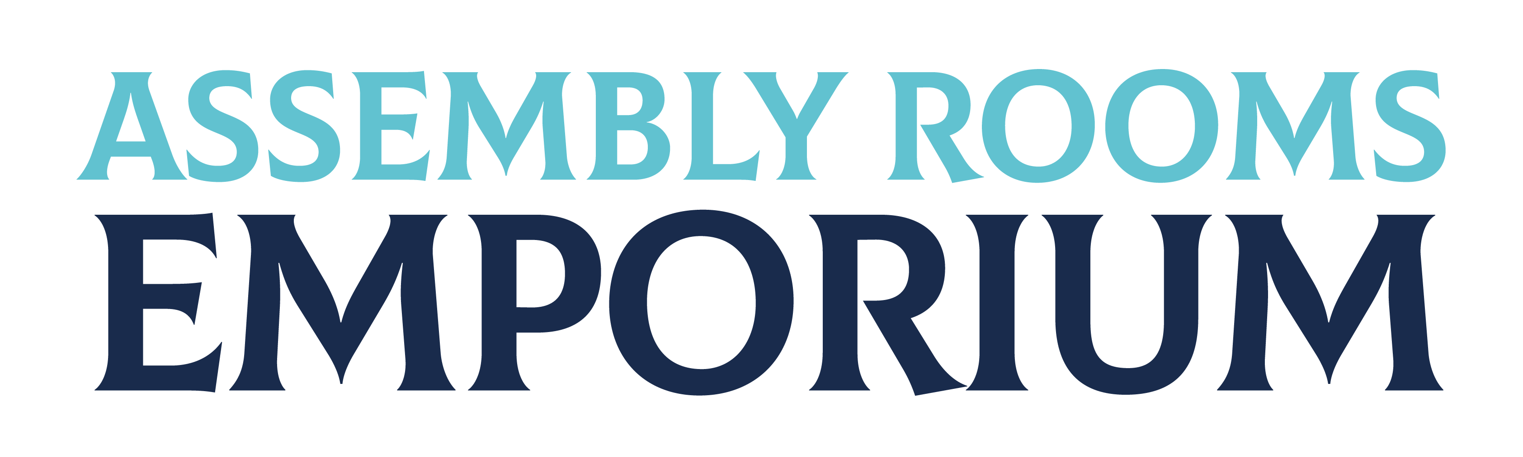
3

Asian Arts & Crafts
Lancaster
Asian arts & crafts; Asian prepacked food & drink; haberdashery & sewing service

6
Renaissance
Upcycled furniture; antiques, collectables & art; handmade pottery & fabric items; ethnic handicrafts

Assembled Books
Books and cards; jigsaws and games; postcards; gemstones, shells, rocks and fossils

Stalls
May 2024

Back Room

B’s Knees
Ladies and gents vintage and upcycled clothes and accessories; toiletries; candles; small household items; ephemera
↑

Entrance
4

5
Celtic Dreams
Silver, vintage and antique jewellery; commissions

1 & 2
Miss Frog Ltd
Novelty, nerdy ‘n’ anime

7

Funki Fancy Dress
Fancy dress, steampunk, goth & alternative clothing & apparel (pre-loved, hand-made & new)
8b

Assembled Books
Incense, candles
8a

Zine Freak
Comics, zines & associated merchandise

9

Merrymoon
Fair trade recycled clothing, accessories, gifts and soft furnishings

