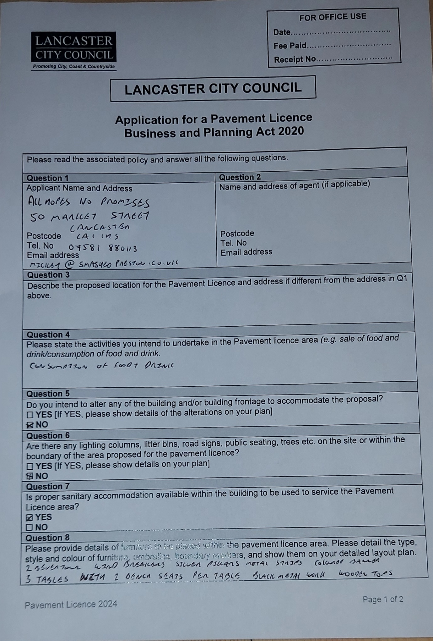

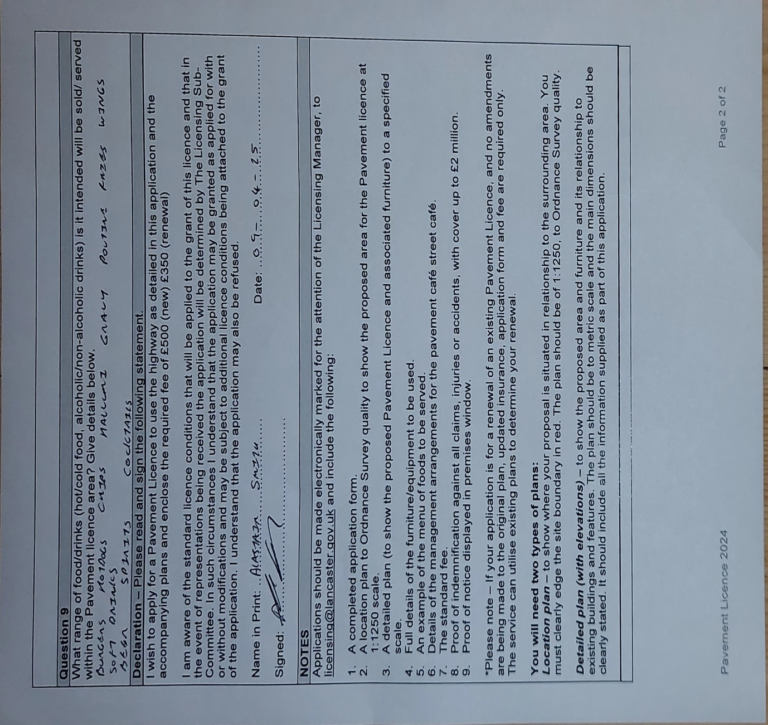

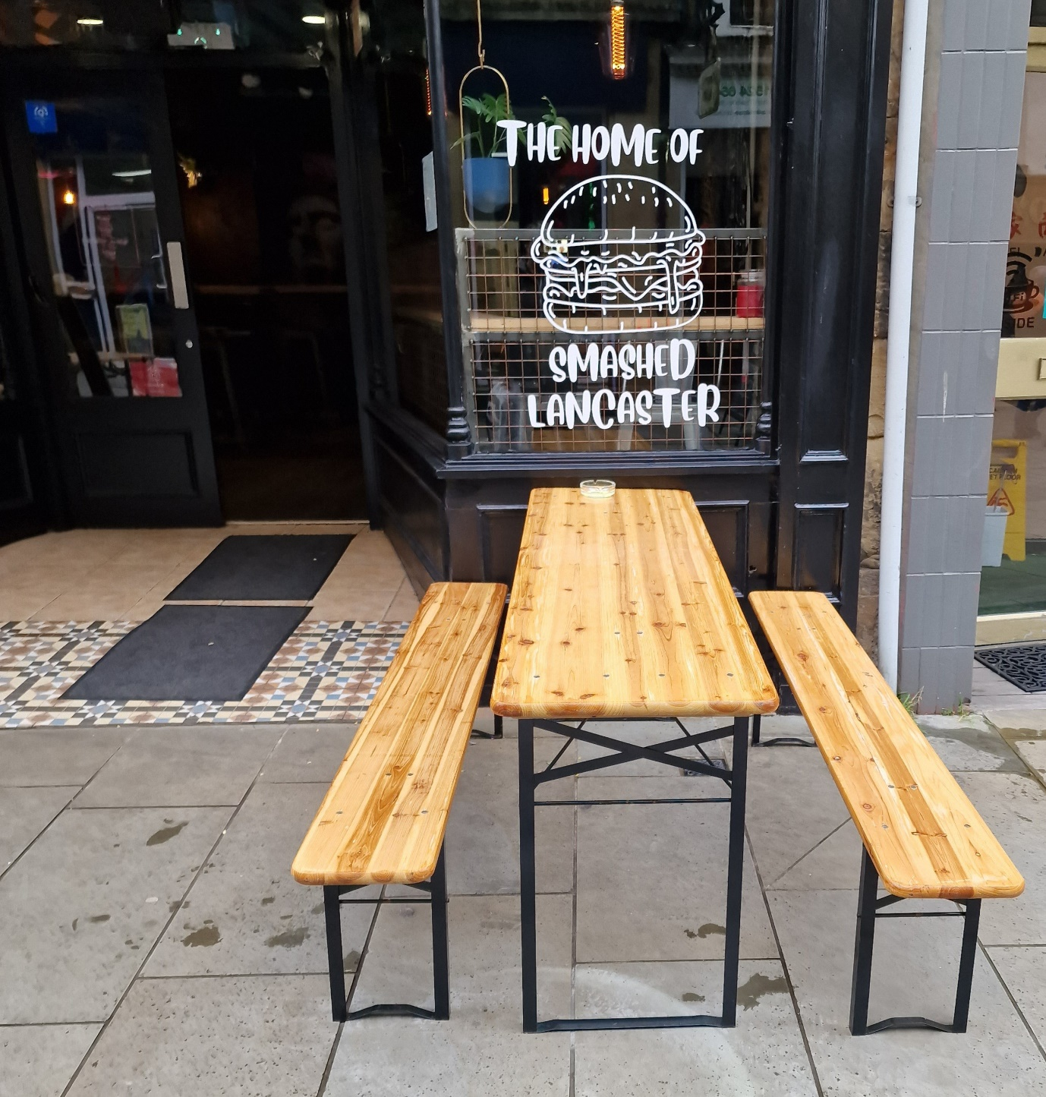

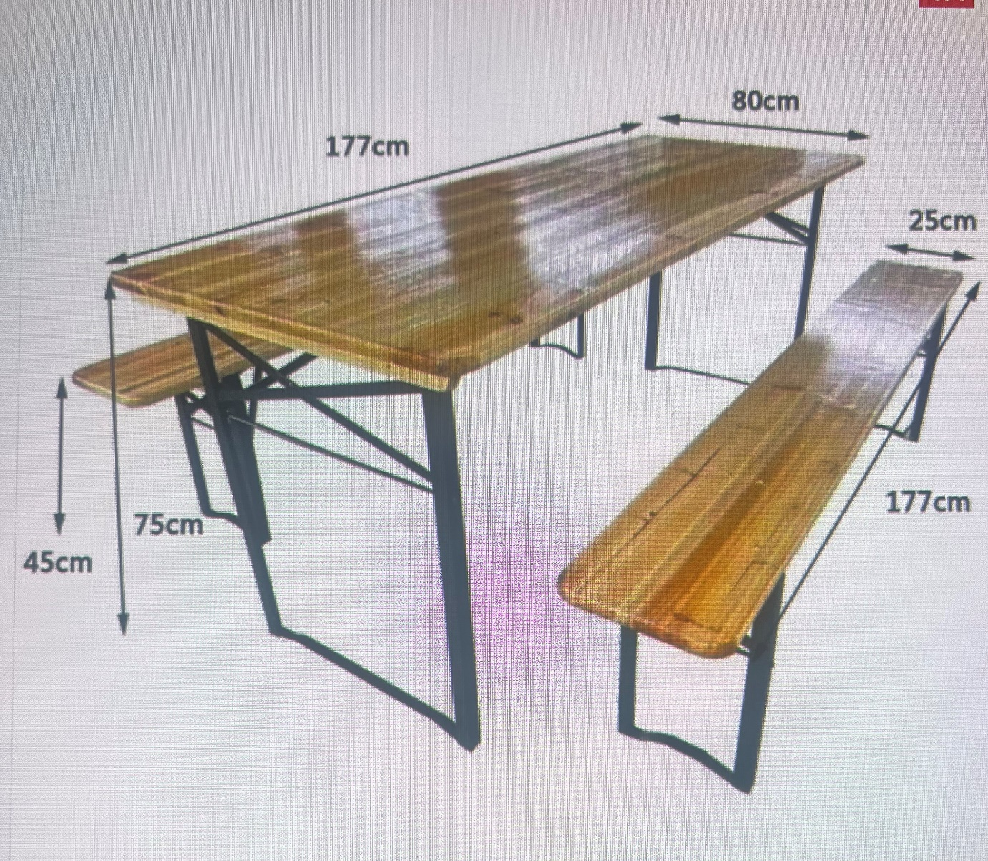

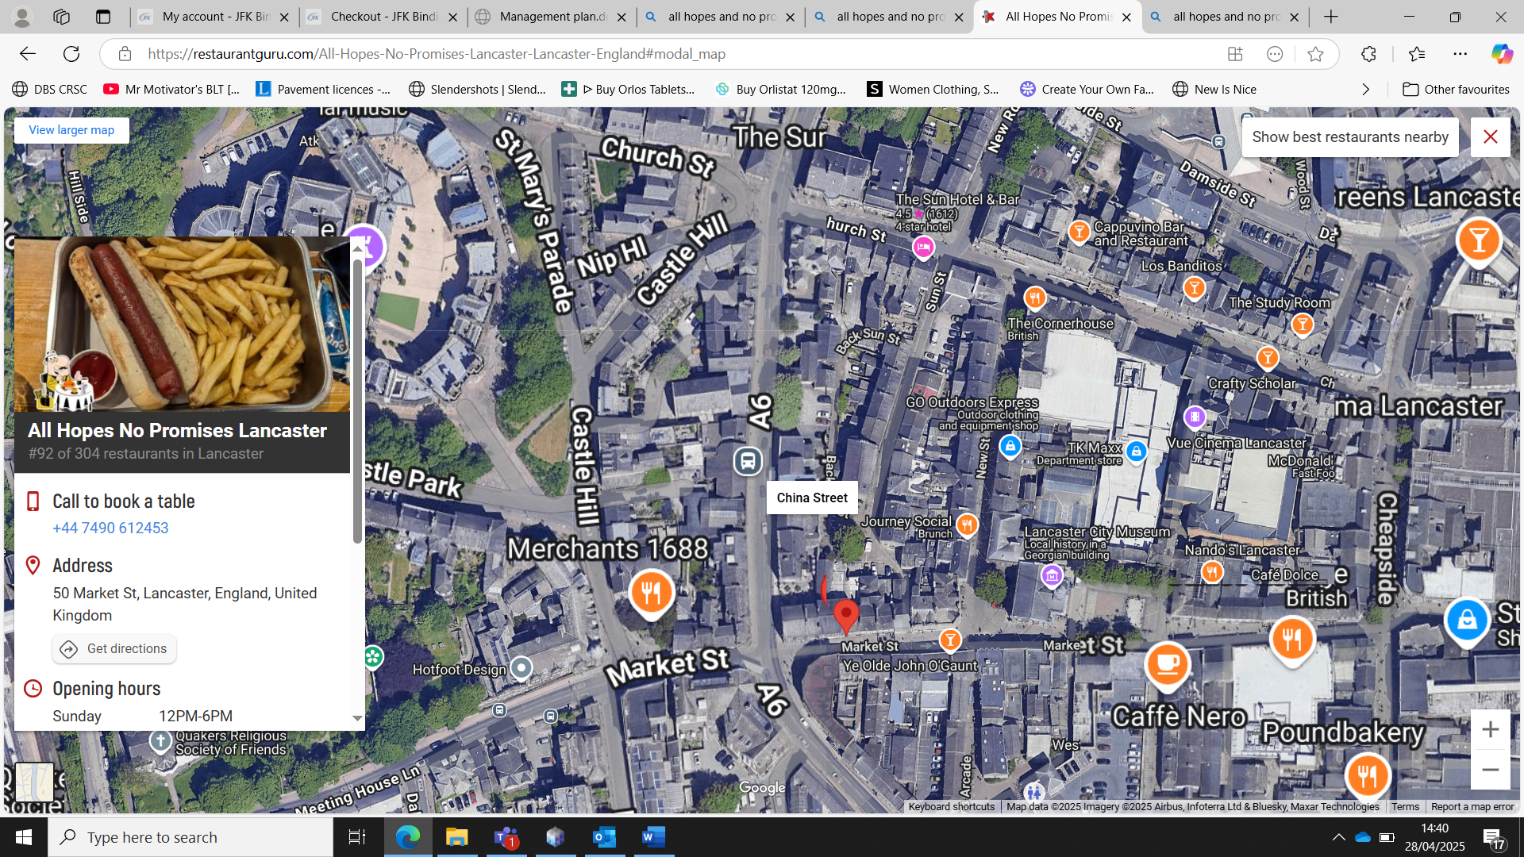




BUSINESS AND PLANNING ACT 2020
Notice of Application submitted to
LANCASTER CITY COUNCIL
In respect of a Pavement Licence for
NAME OF PREMISES]
[FULL ADDRESS OF PREMISES]
NOTICE IS HEREBY GIVEN that in accordance with Business and
Planning Act 2020 (applicant name) has made an application to
Lancaster City Council on (Insert Date) for a Pavement Licence.
The application is in respect of
(Description of the highway area to be utilised e.g area
extending X meters from the frontage of the premises address)
And is seeking permission to utilise a Pavement Licence to facilitate
(description of the activities to be carried on)
The proposed hours of operation are as follows
(please insert days and timings)
A copy of the proposal and accompanying plan are available for
inspection on the Councils website at Licensing applications received
- Lancaster City Council
Any person wishing to make representations to the Council regarding
this application may do so by emailing licensing@lancaster.gov.uk.
The email should be headed Pavement licence representation
(Insert premises name). Alternatively, in writing to the Licensing
Manager, Morecambe Town Hall, Marine Road, Morecambe LA4
5AF to be received no later than 14 days from the date of this
notice.
Dated this th day of 2023/4

