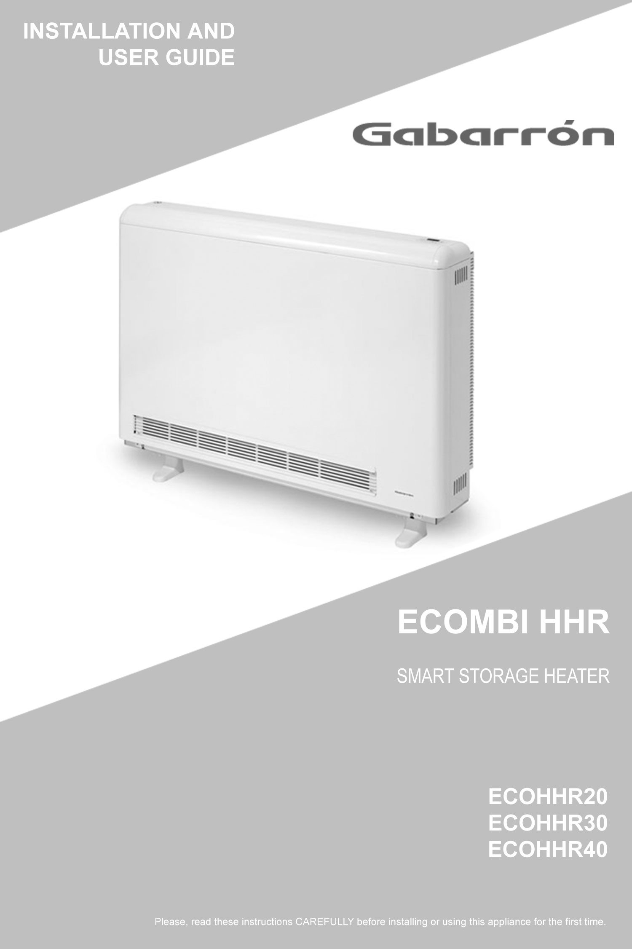



Installation Instructions

IMPORTANT INFORMATION

Please read all the instructions carefully before installing or using the heater for the first time and retain for future use.

WARNING - THE SURFACE OF THIS HEATER CAN BE HOT.
Particular attention must be given where children and vulnerable people are present.

Keep combustible materials, such as furniture, pillows, bedding, papers, clothes and curtains at least 300mm from the front, a recommended 150mm(75mm min) from both sides and 250mm above the heater.

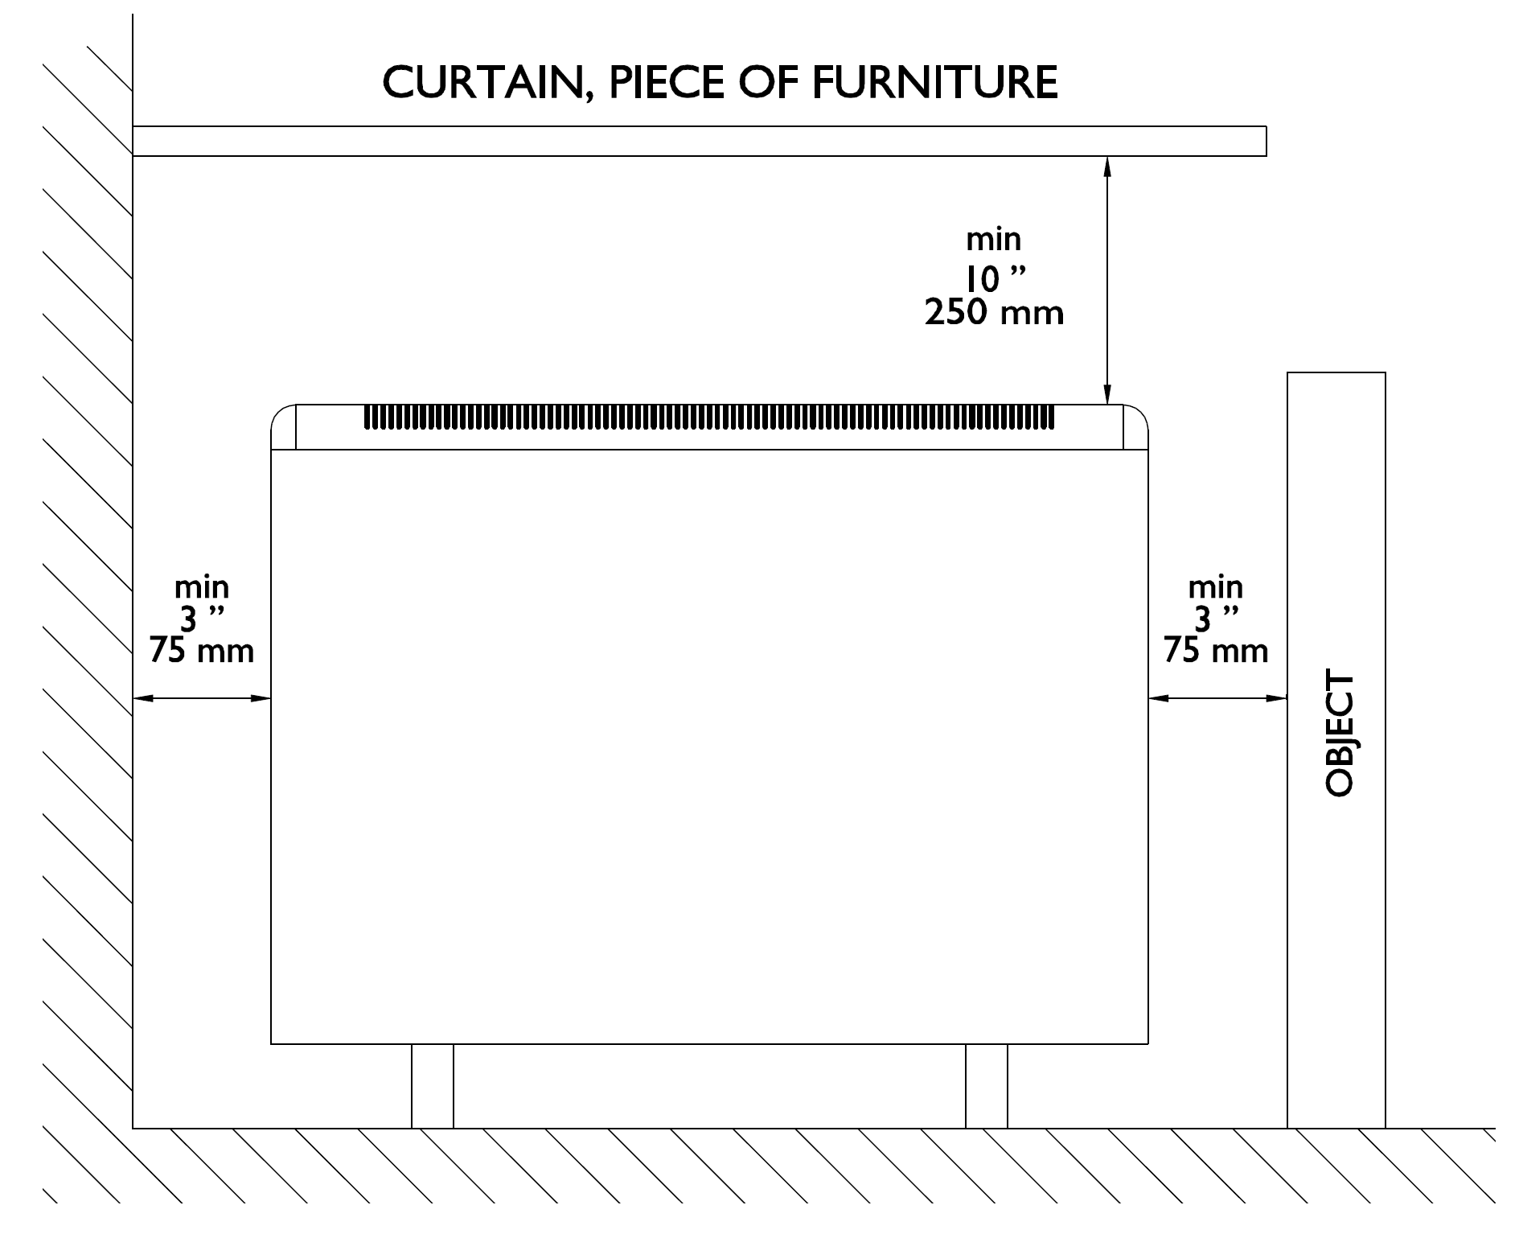

Note: Items such as shelves that are mounted above the heater below the minimum 250mm clearance will affect the performance of the heater.

- Children should be supervised to ensure they do not play with the heater. Extreme caution is necessary when any heater is used by or near children or invalids and whenever the heater is left operating unattended.
- This appliance can be used by children aged from 8 years and above and persons with reduced physical, sensory or mental capabilities or lack of experience and knowledge if they have been given supervision or instruction concerning the use of the appliance in a safe way and understand the hazards involved. Cleaning and user maintenance must not be made by children without supervision.
- Children ages from 3 years and less than 8years shall only switch on/off the appliance provided that it has been placed or installed in its intended normal operating position and they have been given supervision or instruction concerning use of the appliance in a safe way and understand the hazards involved. They also shall not plug in, regulate and clean the appliance or perform user maintenance.
- Children of less than 3 years should be kept away unless continuously supervised.
- Do not operate any heater after it malfunctions. Disconnect and Isolate from the electrical supply and have the heater inspected by a competent electrician or approved service agent before reusing.
- Do not use the heater outdoors.
- To disconnect the heater, turn off the isolator switches and at the consumer unit.
- Do not insert or allow foreign objects to enter any ventilation or exhaust openings as this may cause electric shock, fire or damage to the heater.
- Air inlets and outlets provide proper operation of the appliance and prevent its overheating. DO NOT cover or block the air intake and outlet grills.
- Use this heater only as described in this manual. Any other use is not recommended by the manufacturer and may cause fire, electric shock or injury to persons.
- This guide must be kept and given to any new user.

SAVE THESE INSTRUCTIONS

 | ECOHHR20 | ECOHHR30 | ECOHHR40
Balancing element output W | 550 | 820 | 1100
Storage heater element rating W | 1742 | 2613 | 3484
Charge period | 7h | 7h | 7h
Charging (7h) Kwh | 12.2 | 18.3 | 24.4
Connection | 230-240v~ | 230-240v~ | 230-240v~
Frequency Hz | 50-60 | 50-60 | 50-60
Length cm | 72 | 95 | 117
Height cm | 76 | 76 | 76
Width cm | 19.5 | 19.5 | 19.5
Weight (including blocks) Kg | 97 | 140 | 183
Number of blocks (6kg) | 12 | 18 | 24

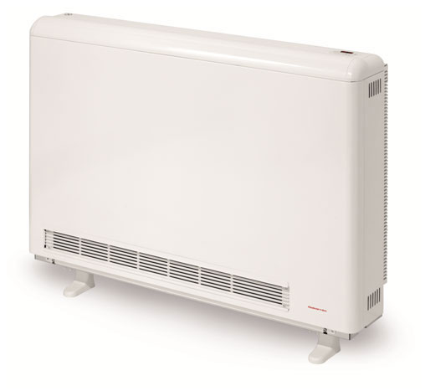

Content for User Installation Instruction

- Warning Messages & Unpacking

- Box Contents & Bracket Distances

- Wiring & Removing Microtherm
Panel

- Installing Bricks & Metal Plate

- Microtherm Installation, Relocation &
Resetting Limiters

Elnur UK Ltd, Unit 1 Brown Street North, Leigh, WN7 1BU
Customer Help Line
01942 670119
Technical Support
01942 265048

1
Installation Instructions

Information symbols used within this manual are as follows:-

WARNING This indication shows the possibility of causing death from electric shock.

WARNING This indication shows the possibility of causing death or serious injury.

CAUTION This indication shows the possibility of causing injury or damage to properties only.

This symbol is for useful information.

IMPORTANT: Wiring procedures and connections should be in accordance to current IEE regulations.

- The warranty of the heater will not cover any damage caused by non observance of any of these instructions.
- The installation must be carried out in accordance with the current IEE regulations. Any installation or reinstallation has to be carried out by a skilled or instructed person.
- Please check that cable, isolation switch gear and power supply is sufficient for the voltage and watts shown on the rating label.
- This appliance must be Earthed.
- This appliance should not be installed just below an electrical socket.
- This appliance must be installed in such a way that it is impossible for anyone using a bath or shower, to touch the controls.
- If during any installation the thermal insulation shows any sign of damage, it must be replaced.
- This heater should be switched off at the isolation switch and/or circuit breaker before any repair work is carried out on the heater.
- This appliance is only intended for a fixed installation with a permanent connection and is not for portable use. After the installation a survey of the first charge cycle should be carried out to ensure that the main input thermostat switches off. Ventilate the room during this first cycle.
- Never open a charged heater, temperatures can raise above 600°C.
- To maintain stability, it is essential that the heater is placed on a level surface and care should be taken to avoid irregular surfaces, such as may result from carpets or tiled surrounds partially protruding under the heater.
- The presence of air particles of smoke, dust, scented candles and other pollutants, could in time, discolour the walls and surfaces around the heater.

In order to achieve a correct installation of this device, follow these steps:

1. Choose the right location to install the Ecombi HHR. The minimum clearances must be respected from the appliance to any combustible material such as furniture or curtains. To reduce the risk of fire, do not store or use petals or other flammable liquids and vapours in the vicinity of the heater.

2. Open the heater box at the indicated side and install the supporting feet without removing the heater.

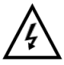





2
Installation Instructions

Check that all parts have been delivered and are intact:
- 1 ECOMBIHHR heater casing.
- 1 Bag containing 2 screws and 2 rawl plugs and 4 white screws.
- 2 supporting feet.
- This guide.
- 1 superior fixing fitting.
- 2 lateral fixing fittings.

The casing and storage bricks are supplied separately. Check the supplied brick packages correspond to the ones indicated on the heater carton.

The heater operation is not affected if bricks with minor damage are used.

3. Screw on the wall the superior fixing fitting, making the two required holes at the recommended distance depending on the model.

Use the rawl plugs and screws contained in the plastic bag to fix the fitting to the wall.

4. Fix the lateral fittings to the metal structure by using the appropriate screws. The supply cables must be fitted but not wired to the storage heater before placing the heater on the wall. Remove the white screws located in the top of ECOHHR, and place the ECOHHR in the selected installation area. Use the removed screws to attach ECOHHR to the superior fixing fitting installed in the wall.

ECOHHR MUST NOT BE HUNG ON THE SCREWS; these are used only to prevent the device from overturning and not to support it. If there is any doubt concerning the wall strength, consult the corresponding construction specialist. The appliances are heavy; it is the installer’s responsibility to ensure the correct installation and wall support of these devices to prevent them from overturning.

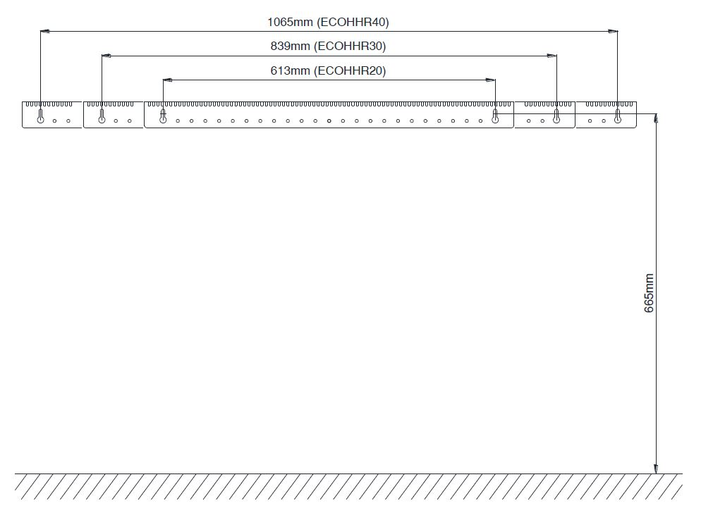

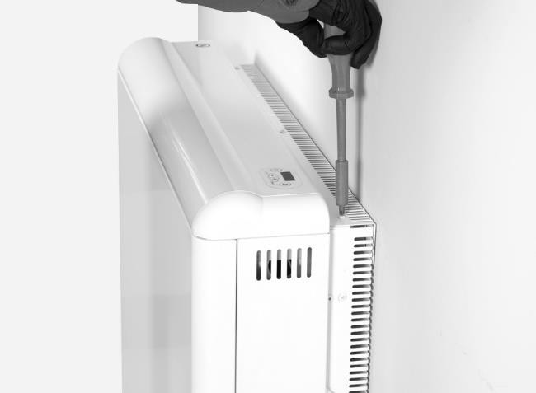

3

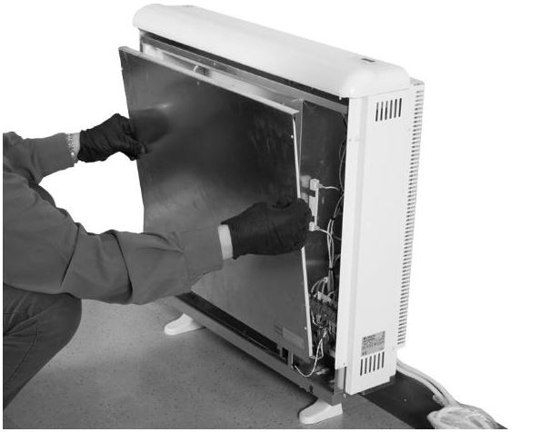
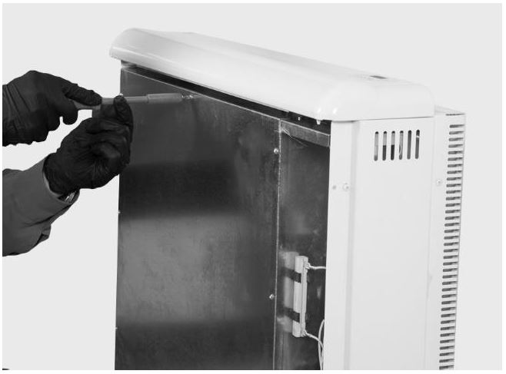
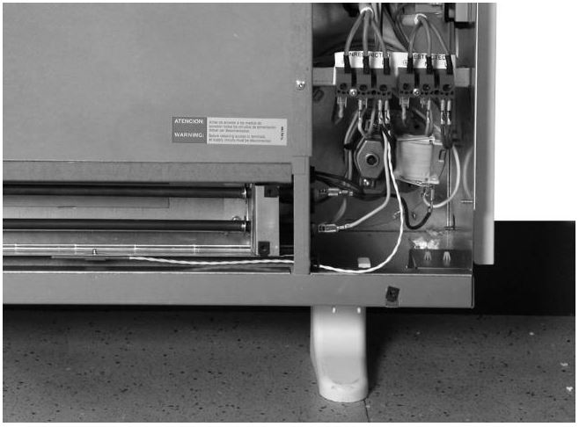
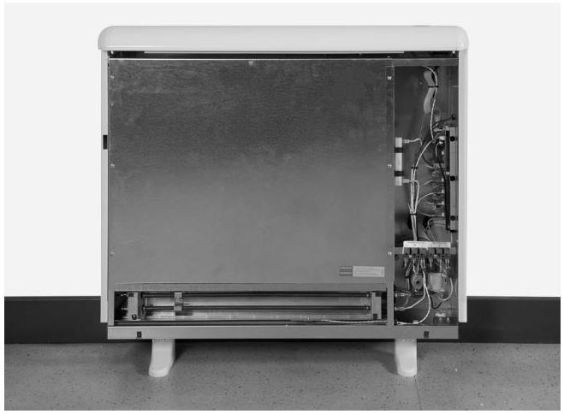
4
5. Take off the front outlet grill by removing the four screws. Take off the front panel by removing the two screws located at the bottom.

6. Connect the heater using the wiring diagram included at the end of this manual. Tighten the connection block screws securely. Do not leave any remaining wire inside the heater.

WARNING Touching live connections can cause serious personal injury.

7. Unscrew the inner panel and remove it.

WARNING Steel edges can cut.

CAUTION In the interior part of this inner panel there is a very delicate thermal insulation MICROTHERM panel. It has to be handled with extreme care. AVOID TOUCHING IT.

Installation Instructions
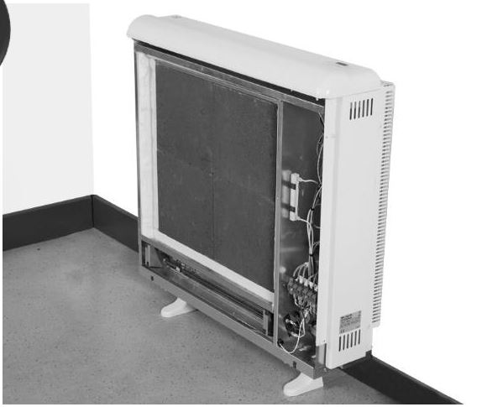
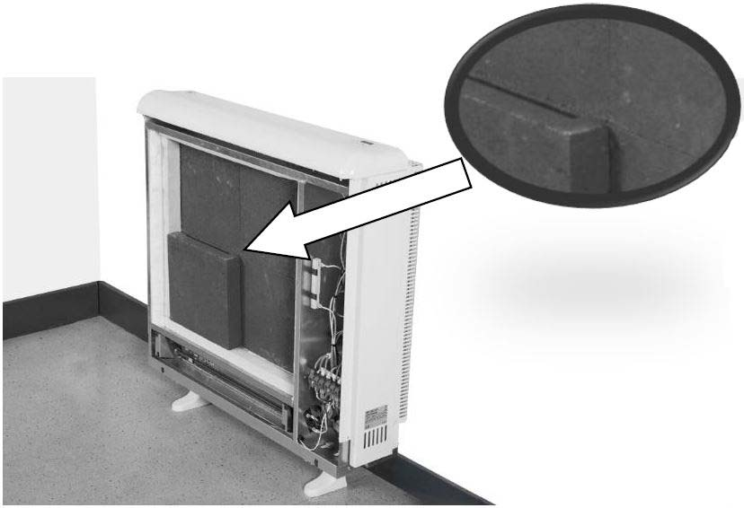
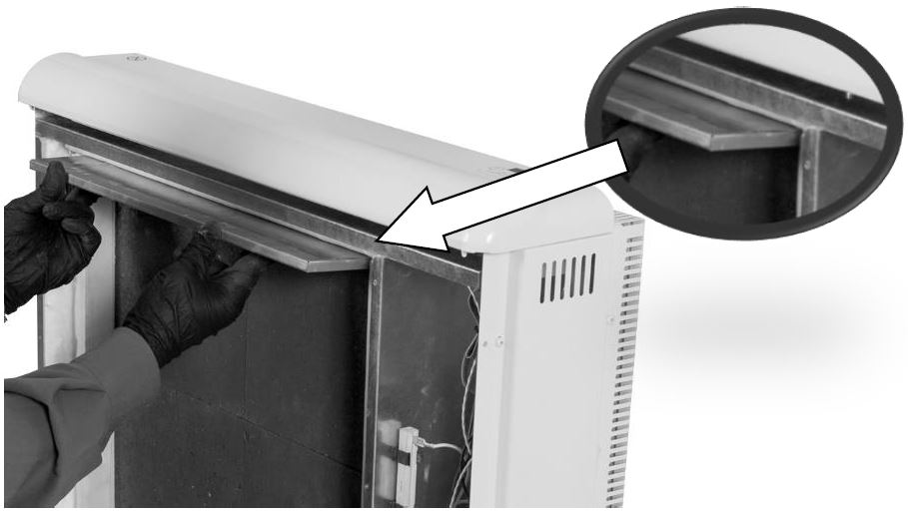
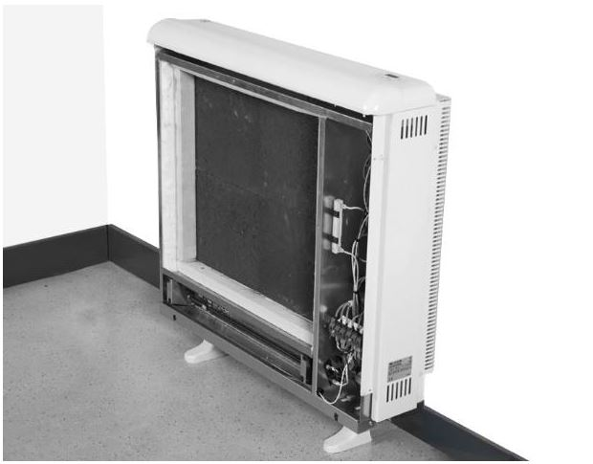
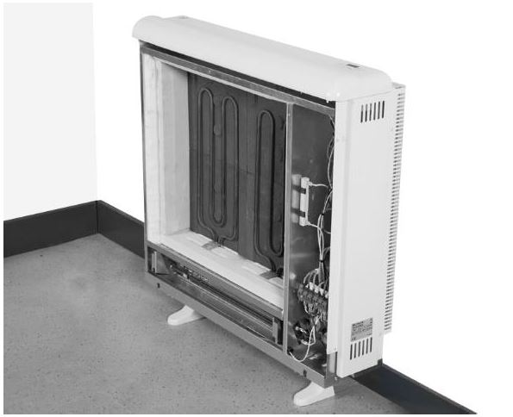
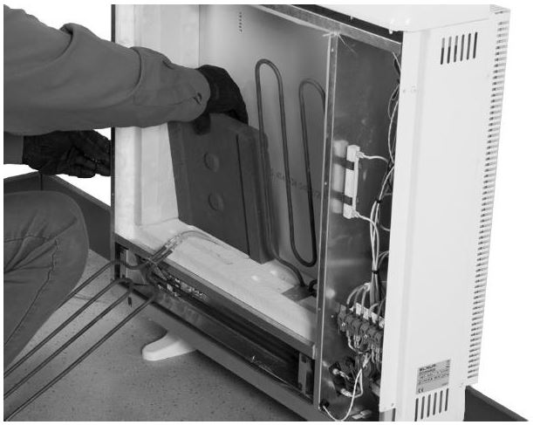
5
8. Do not disconnect the electrical heating elements. Remove the packing cardboard and the metallic part. Lift and tilt the elements outwards being careful not to damage the insulation on the bottom of the heater and carefully place the storage bricks. Arrange two levels of bricks with the flat side facing to the back of the heater.

9. Place the heating elements back into their original position. Place the second row of storage bricks with the flat side facing out and the elements sitting in the indentations.

Next replace the metallic plate in the top of the storage core, between the bricks and the Microtherm insulation panel with the flat side facing up. It must be placed in the right position for the fan to work correctly.

10. Place the second row of storage bricks with the flat side facing out.

11. Place the third row of storage bricks with the flat side facing out.
Installation Instructions
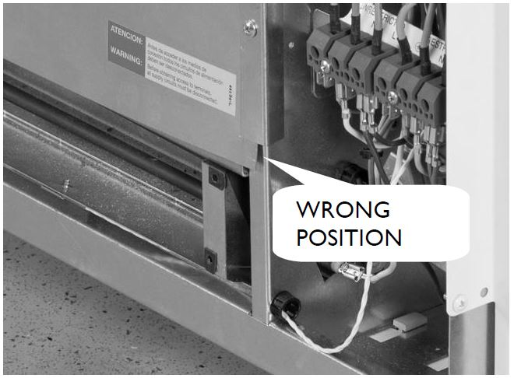
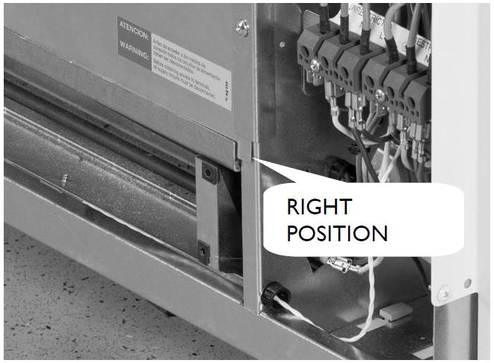
6
12. Refit the inner front panel. If the bricks have been fitted correctly you will have no difficulty in refitting the panel. Make sure the bottom edge of the inner panel is inside the front lip of the heater. Please see below:

13. Replace the front panel with screws. When refitting the exterior front panel, align the 2 plastic upper pegs on the heater with holes in the exterior panel. Push the top up into place and push the bottom and fix the panel with the removed screws.

14. Refit the front outlet grill with the screws.

RELOCATION

WARNING: Relocation to another location must be carried out by an experienced technician.

If during reinstallation the thermal insulation shows any sign of damage, it must be removed and replaced by an identical part.

MANUALLY RESET TEMPERATURE LIMITER

This heater employs a manually reset temperature limiter (see CUT OUT in the connection diagram).

This safety device operates when high temperatures are reached at the top of the heater. It requires re-setting manually:
Let the heater cool. The cause of overheating should be investigated.

WARNING: Re-setting manually must be carried out by an experienced technician only.

Turn off the heater at the circuit breaker.

Take off the front panel by removing the two screws located at the bottom. Find the limiter CUT OUT in the connection diagram and push the small pin until a click is heard.
Installation Instructions

User Operating Instructions

IMPORTANT INFORMATION

Please read all the instructions carefully before installing or using the heater for the first time and retain for future use.

WARNING - THE SURFACE OF THIS HEATER CAN BE HOT.
Particular attention must be given where children and vulnerable people are present.

Keep combustible materials, such as furniture, pillows, bedding, papers, clothes and curtains at least 300mm from the front, a recommended 150mm(75mm min) from both sides and 250mm above the heater.

Note: Items such as shelves that are mounted above the heater below the minimum 250mm clearance will affect the performance of the heater.

- Children should be supervised to ensure they do not play with the heater. Extreme caution is necessary when any heater is used by or near children or invalids and whenever the heater is left operating unattended.
- This appliance can be used by children aged from 8 years and above and persons with reduced physical, sensory or mental capabilities or lack of experience and knowledge if they have been given supervision or instruction concerning the use of the appliance in a safe way and understand the hazards involved. Cleaning and user maintenance must not be made by children without supervision.
- Children ages from 3 years and less than 8years shall only switch on/off the appliance provided that it has been placed or installed in its intended normal operating position and they have been given supervision or instruction concerning use of the appliance in a safe way and understand the hazards involved. They also shall not plug in, regulate and clean the appliance or perform user maintenance.
- Children of less than 3 years should be kept away unless continuously supervised.
- Do not operate any heater after it malfunctions. Disconnect and Isolate from the electrical supply and have the heater inspected by a competent electrician or approved service agent before reusing.
- Do not use the heater outdoors.
- To disconnect the heater, turn off the isolator switches and at the consumer unit.
- Do not insert or allow foreign objects to enter any ventilation or exhaust openings as this may cause electric shock, fire or damage to the heater.
- Air inlets and outlets provide proper operation of the appliance and prevent its overheating. DO NOT cover or block the air intake and outlet grills.
- Use this heater only as described in this manual. Any other use is not recommended by the manufacturer and may cause fire, electric shock or injury to persons.
- This guide must be kept and given to any new user.
SAVE THESE INSTRUCTIONS

 | ECOHHR20 | ECOHHR30 | ECOHHR40
Balancing element output W | 550 | 820 | 1100
Storage heater element rating W | 1742 | 2613 | 3484
Charge period | 7h | 7h | 7h
Charging (7h) Kwh | 12.2 | 18.3 | 24.4
Connection | 230-240v~ | 230-240v~ | 230-240v~
Frequency Hz | 50-60 | 50-60 | 50-60
Length cm | 72 | 95 | 117
Height cm | 76 | 76 | 76
Width cm | 19.5 | 19.5 | 19.5
Weight (including blocks) Kg | 97 | 140 | 183
Number of blocks (6kg) | 12 | 18 | 24

Content for User Operating Instruction

1. Connection and Disconnection and
Brief overview on the Control Panel

2. Setting the Day and Time

3. Setting the Comfort Temperature Level
Setting the Economy Temperature Level

4. Setting the Weekly Programming

5. Weekly Programming (continued)
Copying programmed days

6. Economy Mode Override Function
Control Panel Child Lock Function

7. ECOHHR Current Status Function
Cleaning your ECOHHR heater

7
Elnur UK Ltd, Unit 1 Brown Street North, Leigh, WN7 1BU
Customer Help Line
01942 670119
Technical Support
01942 265048

User Operating Instructions

Connection and Disconnection

Each ECOHHR storage heaters has its own power switch and is located on the right side panel. The power switch is used to turn the heater ON and OFF.

If this switch is turned OFF then the storage heater will not take a charge when the off peak supply is on and will not give out any heat. Therefore it is important to make sure this is turned ON at all times.

Each ECOHHR storage heater requires two electrical supplies. One is an economy tariff supply (off peak or restricted supply) and the other is a 24hr supply (on peak or unrestricted supply).

Connection from the economy supply (off peak or restricted supply) to the heater should be via a 20Amp double pole isolator switch.
Connection from the 24hr supply (on peak or unrestricted supply) to the heater should be via a fused double pole isolator switch or a fused RCD isolator switch, depending on the installation.

Note: Two electrical supplies needed.
Economy and 24hr supply.

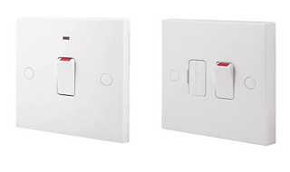

User Control Panel

You will find the keypad on the top right side on the heater. This easy to use keypad only has four buttons, however these four button can be use in different ways to give you many functions and will be explained in more detail in later sections.

Basic Key functions:

This button is used to set the 'Comfort'
temperature. Default is 21°C.

This button is used to set the 'Economy'
temperature. Default is 18°C.

This button is used to decrease values.

This button is used to increase values.

and Pressing these buttons together will allow
you to set the Day and Time.

and Pressing these buttons together will allow
you to set the weekly program.
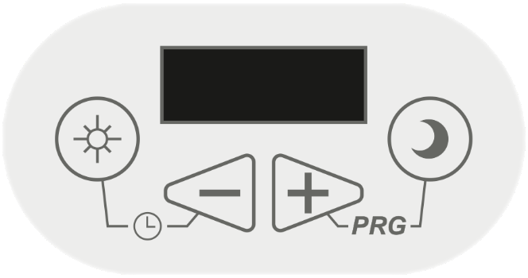





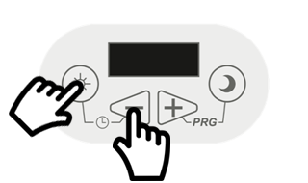





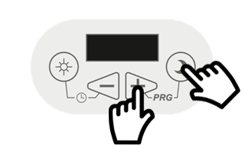

8

User Operating Instructions

Setting the Day/Time

The ECOHHR storage heater has been preset with the Day and Time however you will need to adjust this with summer and winter times (when the clocks go forward and back).

To check the Day and Time on your ECOHHR storage heater follow these steps.

and Press and Release the sun button and the minus button together and the display will first show the Day and then the current Time.

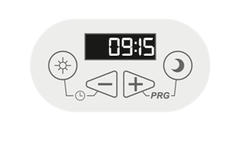
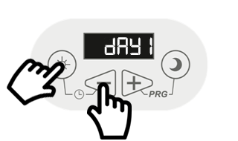




If the Day or Time are incorrect and you want to change then follow these steps.

and Press and Hold the sun button and the minus button together until the Day is displayed and starts to flash. Use the plus
or minus buttons to adjust to the current Day.

and Press and Release the sun button and the minus button together to set the Day and move onto the Time.
The Hour will now start to flash. Used the
plus or minus buttons to adjust to the current hour time.

and Press and Release the sun button and the minus button together to set the Hour and move onto the Minute.
The Minutes will now start to flash. Used the plus or minus button to adjust to the current minutes time.

and Press and Release the sun button and the minus button together to set the Minutes and to finish.

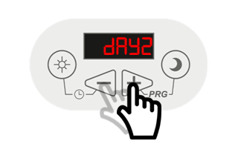
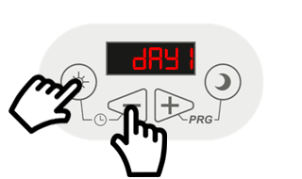



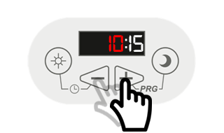
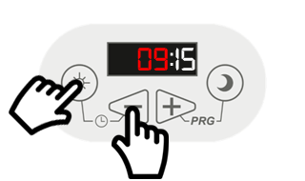

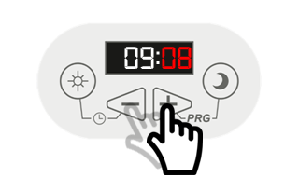
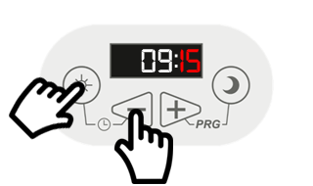

9

User Operating Instructions

Setting the Comfort Temperature Level

The ECOHHR storage heater has been preset with a Comfort temperature level of 21°C.

To increase or decrease the Comfort temperature level please follow these steps.

Press and Release the sun (comfort) button.
The word SUN will be displayed for a short time
and then the current set temperature for the
comfort level will start to flash. Used the plus or
minus button to adjust the comfort temperature.

Press and Release the sun (comfort) button
again to set the new comfort temperature level.

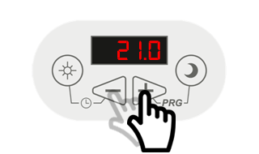
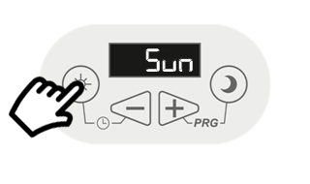

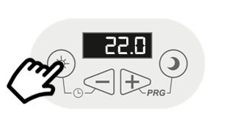

10

Setting the Economy Temperature Level

The ECOHHR storage heater has been preset with an Economy temperature level of 18°C.

To increase or decrease the Economy temperature level please follow these steps.

Press and Release the moon (economy) button
The word Noon will be displayed for a short time
and then the current set temperature for the
economy level will start to flash. Used the plus
or minus buttons to adjust the economy
temperature.

Press and Release the moon (economy) button
again to set the new comfort temperature level.

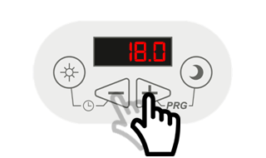
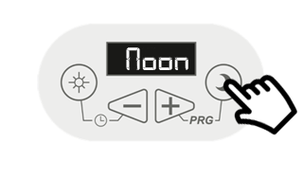


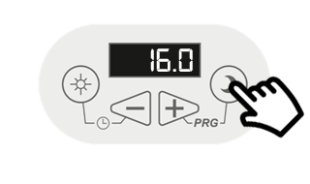

User Operating Instructions

Default Weekly Program

The ECOHHR storage heater has been preset with an economical weekly program designed to give the best efficiencies and is based on the following times.

From 00:00 till 07:00am the program runs in economy mode at 18°C, from 07:00am till 09:00am the program runs at the Comfort temperature of 21°C, from 09:00am till 17:00pm the program will run in economy mode at 18°C, from 17:00pm till 22:00pm the program will be at the Comfort temperature 21°C and from 22:00pm till 24:00pm will run in economy mode.
Default weekly program set for all 7 days.
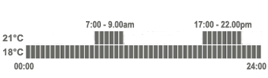

11

Setting the Weekly Program

If you wish to change the default weekly program then follow the next steps. Please note by changing the economy times you may increase the running costs and reduce the efficiency of the heater.

We suggest that you first make a note of the times when you want the heater to be at the Comfort and Economy temperatures.

Press and Release the moon (economy) button and the plus button at the same time. The word ProG will display for a short time and then dAY1 will flash.

Used the or button to select the day you wish to
change the programming for. Then Press and Release the
moon (economy) button and the plus button at the same time to select and enter the program for that day.

The display will now flash between the time interval 00:00
and the set temperature level Noon (Economy setting)

If you wish to change the temperature level from Noon (Economy) to Sun(Comfort) for this 30 minute segment
00:00 to 00:30 then Press the sun (comfort) button. The display will now flash between the time interval 00:00 and Sun(Comfort).

Now Press the Plus button to move to the next 30 minute segment. The display will now flash between the time interval 00:30 and this temperature level

(If you want to keep the current setting of Noon (economy)
or Sun(Comfort) then just Press the plus button to
move to the next 30 minute segment.)

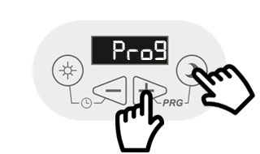
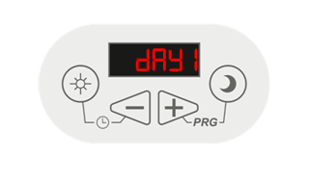




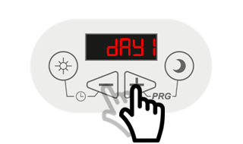
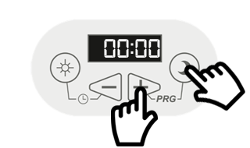

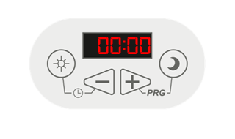
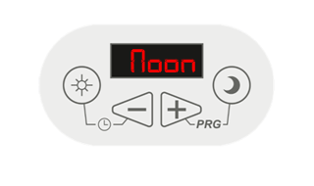

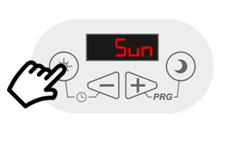

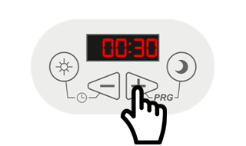

Continued on page 5.

User Operating Instructions

Setting the Weekly Program - continued

If you wish to change the temperature level from Noon (Economy) to Sun(Comfort) for this 30 minute segment
00:30 to 01:00 then Press the sun (comfort) button. The display will now flash between the time interval 00:30 and Sun(Comfort).

Now Press the Plus button to move to the next 30 minute segment. The display will now flash between the time interval 00:30 and this temperature level

Repeat the above steps, selecting either the Sun(Comfort) temperature or Noon(Economy) temperature and pressing the Plus button to move to the next 30 minute segment.

You repeat this until you go through all the 30 minute segments and the display shows dAY1 again.

At this point you can either Press the Plus button and repeat the above for day 2 and the other days or copy day1 to day2, day2 to day3, day3 to day4, and so on.

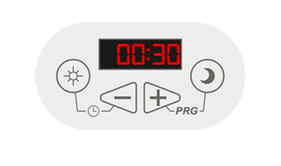

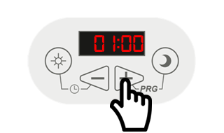

Repeat above steps and go through all 24 hours until dAY1 (or programmed day) is displayed again.

Setting the Weekly Program - Copying Days

To copy dAY1 to dAY2. (while on the day you want to copy)
Press and Hold the Plus button until CP12(copy day 1 to day 2) is displayed and then release. After a short time the display will show dAY1 again.

Press and Release the button to move to day 2, dAY2 is now displayed.

To copy dAY2 to dAY3.
Press and Hold the Plus button until CP23(copy day 2 to day 3) is displayed and then release. After a short time the display will show dAY2 again.

Press and Release the button to move to day 3, dAY3 is now displayed.

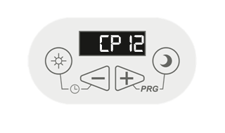
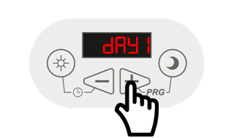

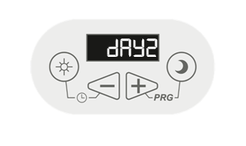

12
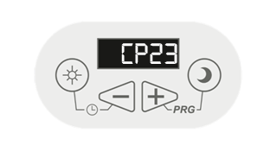
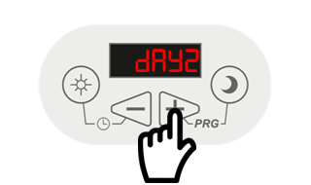

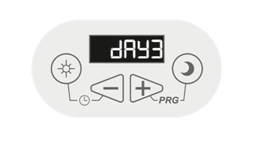

Repeat as above and go through copying each day. Once you have gone through all the days the display will show the set temperature as you have programmed.

User Operating Instructions

Economy Mode Override Function

At some point you may wish to temporally override your current running program from Economy to the Comfort temperature.

To override the Economy Mode you’ll need to follow these steps.

Press and Hold the sun (comfort) button until the word Sun is displayed. The heater will now maintain the comfort temperature until the next programmed change. At which point the heater will then continue to run your current program.

Control Panel Child Lock Function

The ECOHHR storage heater has a built in child lock function that allows you to block any unwanted changes to the heaters settings by disabling the control panel.

To lock the control panel :-
Press and Hold the plus and minus buttons until
[ - - ] is displayed. The heaters control panel is now locked and will now not allow anyone to use or change anything.

To unlock the control panel :-
Press and Hold the plus and minus buttons until
the temperature is displayed. The heaters control panel is now unlocked and will now allow anyone to use again.

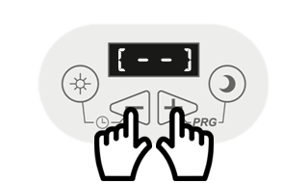

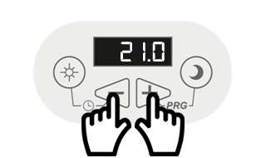

13
User Operating Instructions

ECOHHR Current Status Function

The ECOHHR has a function that allows you check the current status of the heater. This function allows you to see what temperature the heater is currently measuring the room to be, the current core temperature, the air temperature at the grille, the percentage of charge the heater tried to take last period and how long the balancing element has been used for during the last on peak time.

To check the current Status :-
Press and Release the sun and the moon buttons together. The display will now show the current room temperature that the sensor is measuring.

Now Press and Release the plus button to see the current Core temperature.

Now Press and Release the plus button to see the current Air temperature at the grille.

Now Press and Release the plus button to see the last charge percentage.

Now Press and Release the plus button to see how long the balancing element had been on for during the last 24hrs.

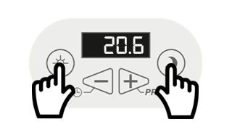

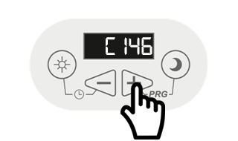

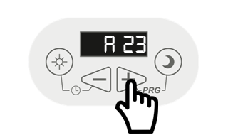

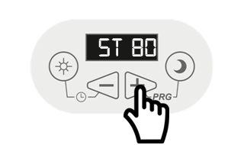

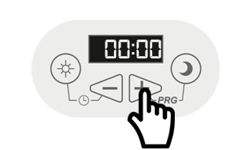

Cleaning your ECOHHR

Before cleaning, make sure the power has been turned off and the heater is cold to touch.

Occasionally, clean dust with a dry, soft cloth.
Do NOT use any solvent or abrasive products for cleaning.

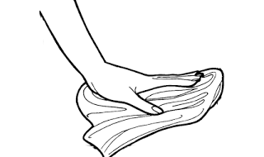

14

